1. The logger.log file is different from the log to console because the logger file lists all the logs, including the FINER logs, where as the console log just lists the import INFO ones.
2. It comes from the external library that is provided by JUnit 5 testing
3. It makes sure that an exception is thrown.
4. See TimerException and there are 3 questions
   1. It is a unique identifier that is used to verify that the sender and receiver of an object is using the same object
   2. We need to override the constructors because we are calling them with our own class and serialized identifier
   3. We do not need to override other methods because we are not using them and the default is fine for our uses.
5. It is an easy way to initialize the class, as it only gets called once, and does not affect the rest.
6. The .md file extension is used to notify that the file is written in Markdown. Its related to bitbucket because that is what their server uses for formatting text
7. The test is failing because the time is set to null, removing this solves the issue.
8. The actual issue is that a NullPointerException is thrown before the TimerException is thrown.
9. Make a printScreen of your eclipse JUnit5 plugin run (JUnit window at the bottom panel)
10. Make a printScreen of your eclipse Maven test run, with console
11. TimerException is a UserDefinedException, NullPointerException is a runtime exception
12. Push the updated/fixed source code to your own repository.

9. 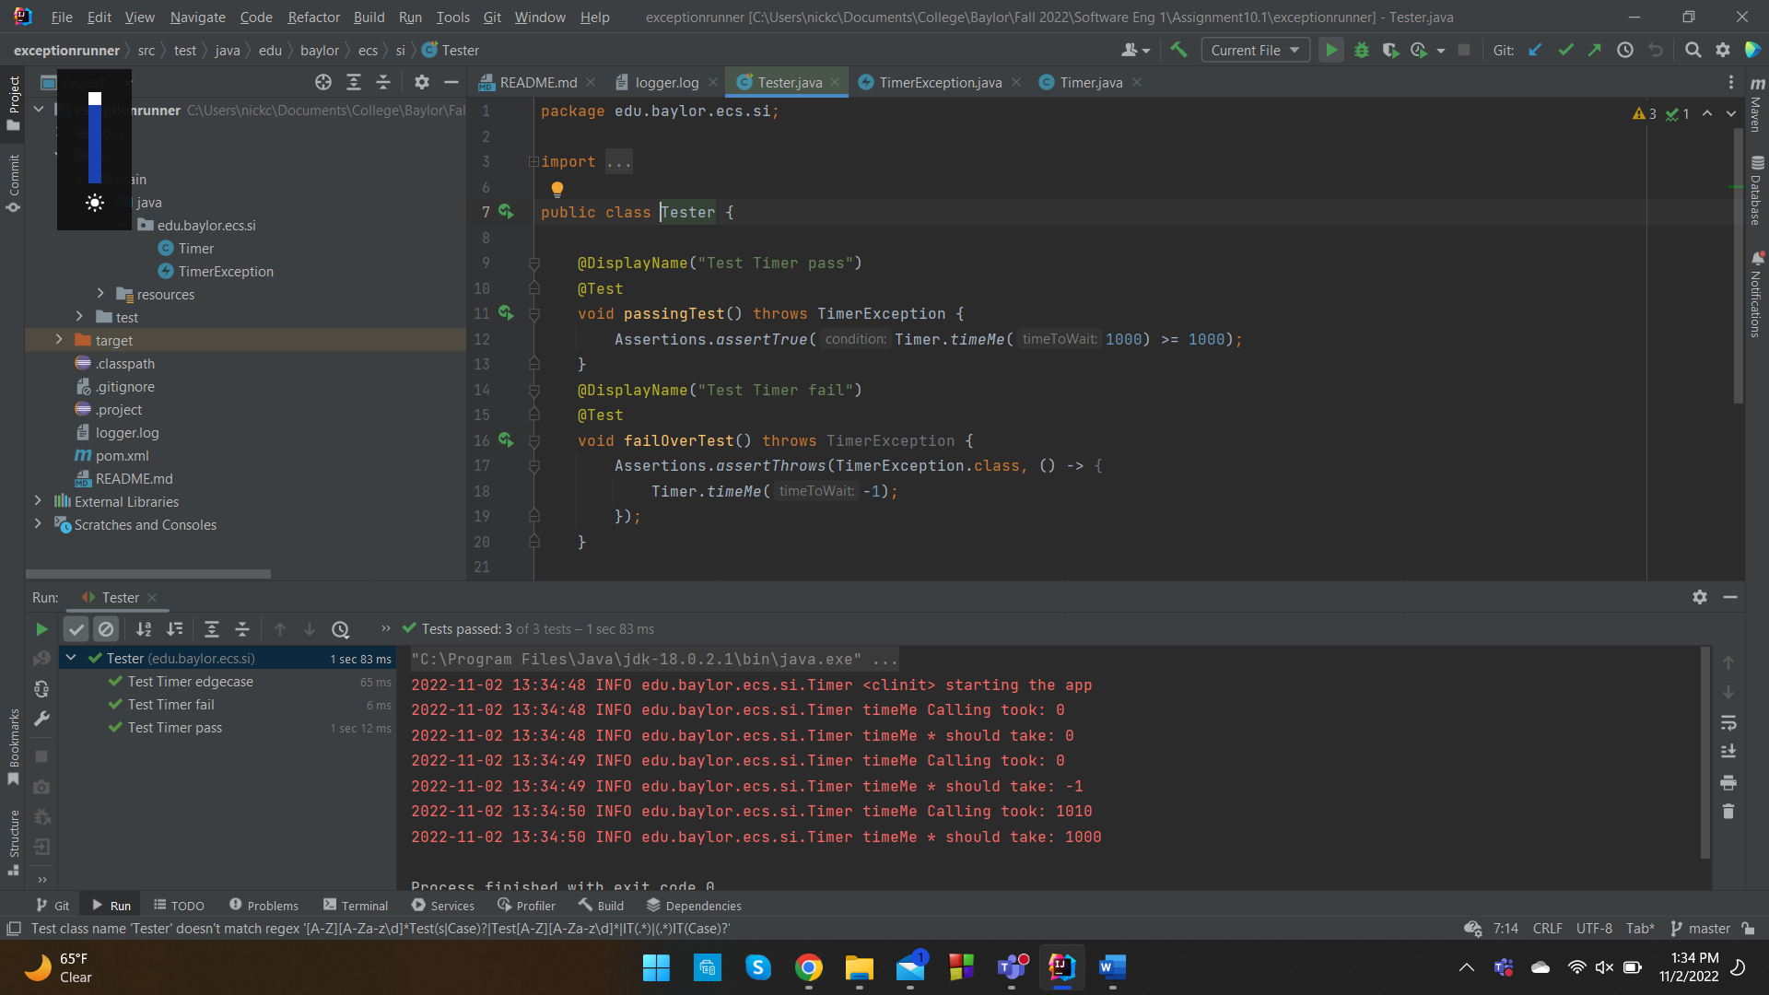

10. 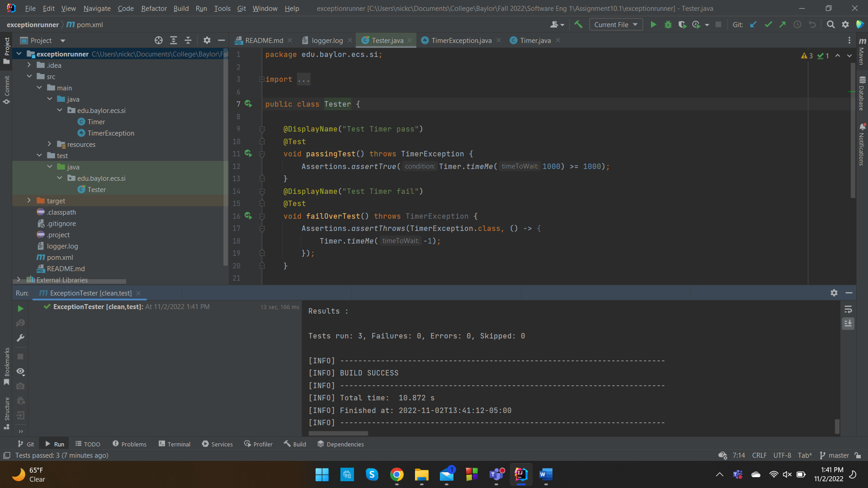

Repository Link: <https://github.com/nookincookin/assignmentX>